Electronic Devices and Circuits
EE-1004
Lab Project
Fall 2025

Construction a Common Source Amplifier for given specifications
Submitted by:
Muhammad saad khan 24i-6550.
Abdul hadi 24i-6538.

National University of Computer and Emerging Sciences, Islamabad

Final project report :
Introduction:
In this project , a single stage common source amplifier is used with a MOSFET.
A 3 inch by 3 inch PCB is used. The pcb is designed then etched, drilled and after it placed the components on it. The board has MOSFET , load and source resistors according to the calculations ,coupling and bypass capacitors, connectors and the connectors for the input output signal . most parts are being placed compactly so that the signal flows very clearly without any kind of noise .
After soldering , we had the working amplifier circuit with 24mV peak to peak sine wave with a frequency of 50 hz. Then 18V supply is provided and then to measure the different voltages , probes are placed at various points on the circuit. Final circuit looks like a small , neatly wired circuit that is measured in the lab.
Calculations :
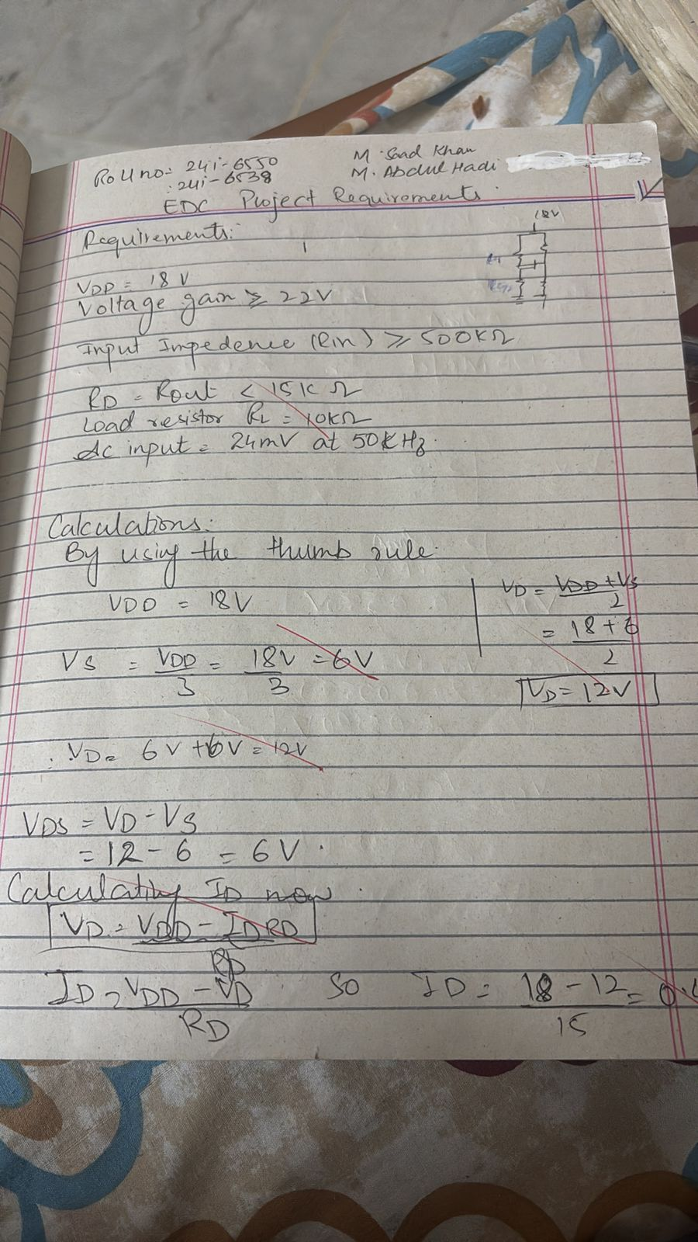
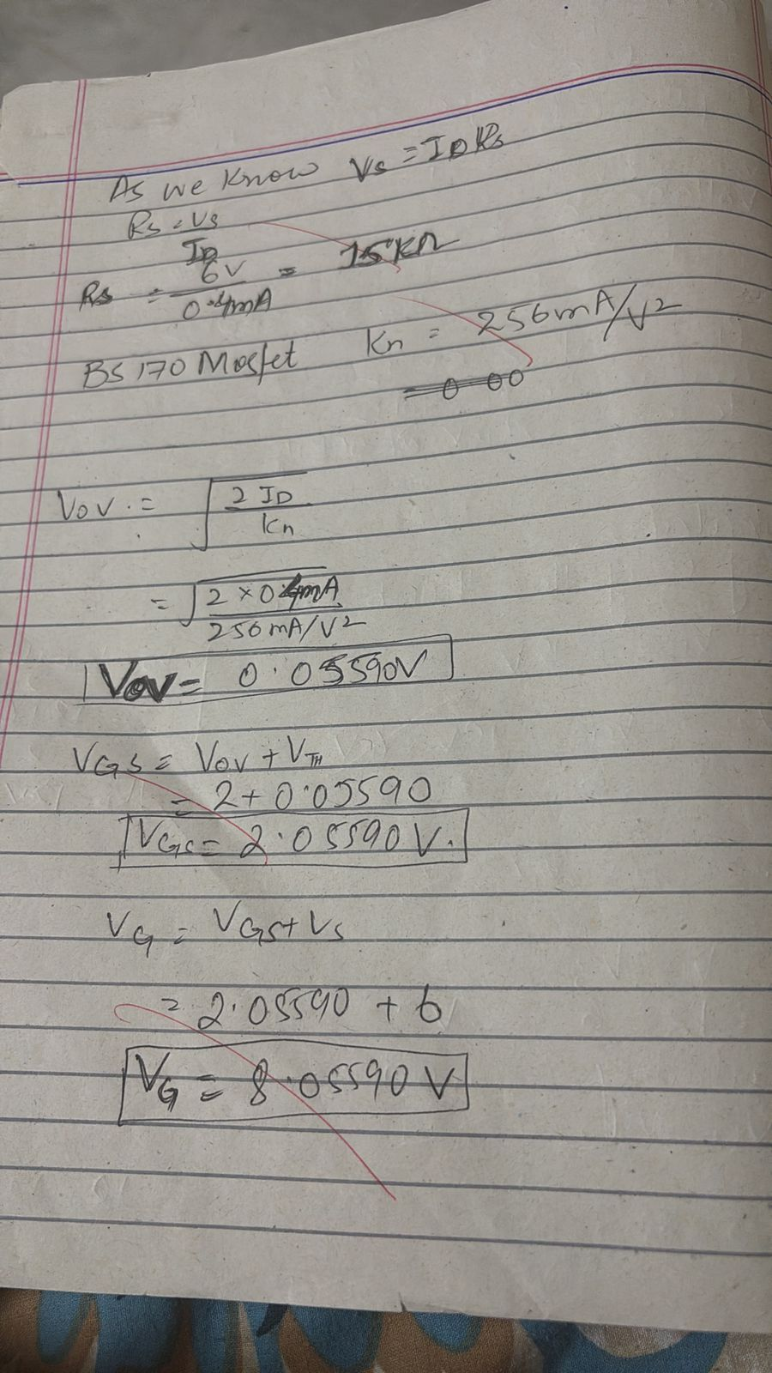
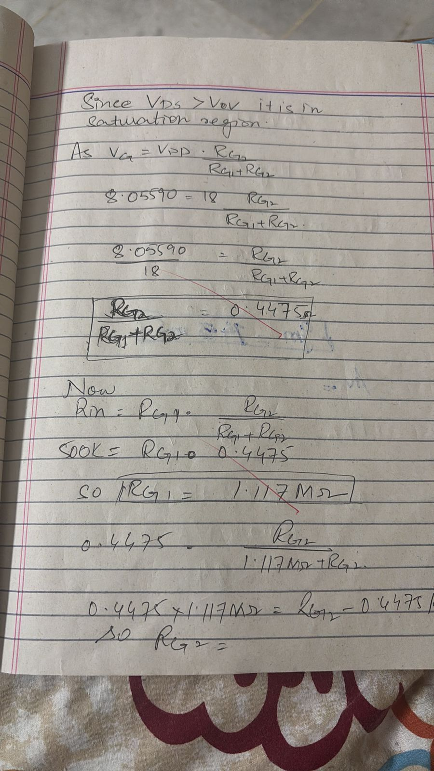
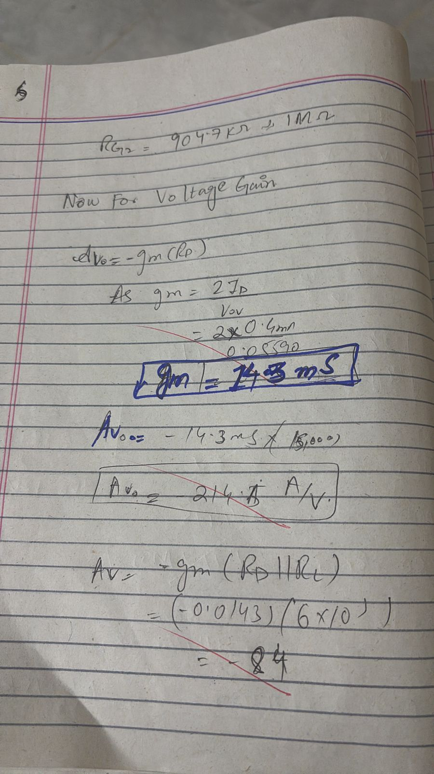
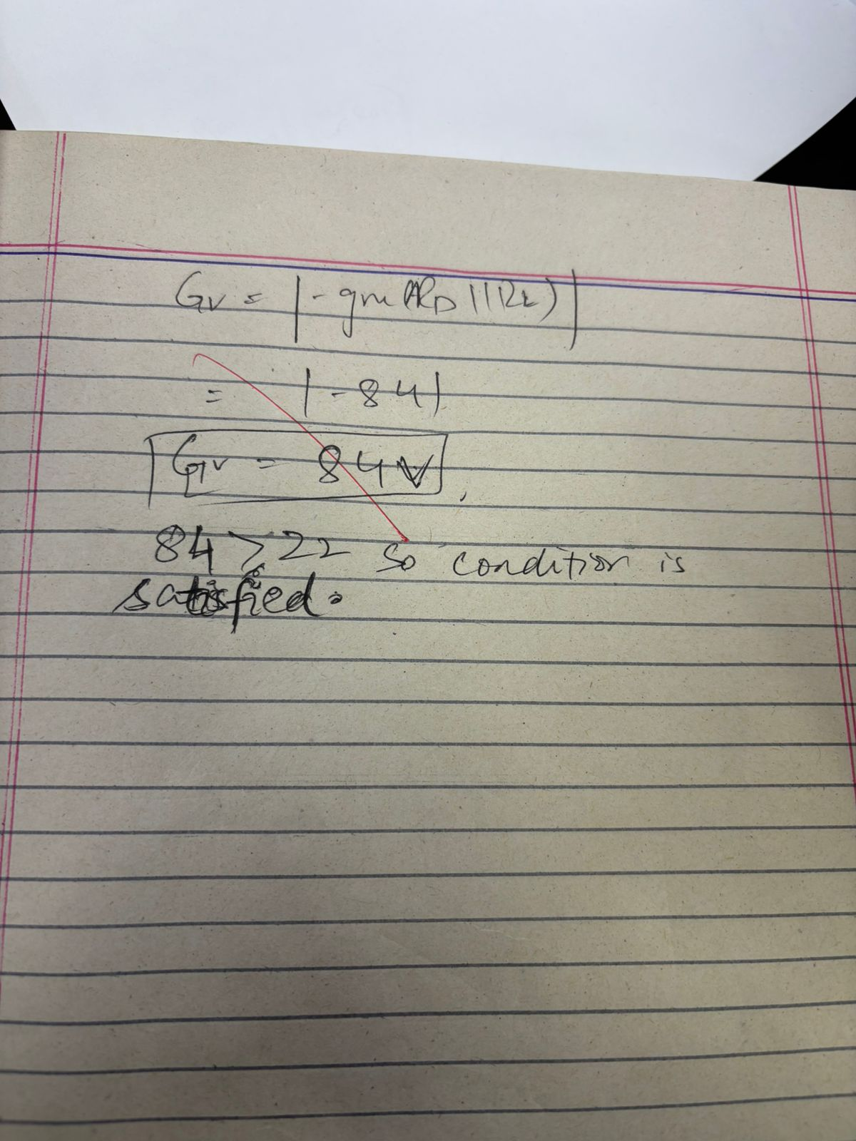

Parts list:
1 X BS170 mosfet .
1 X 100 KOHMS fixed resistor.
1 X 100 KOHMS variable resistor (potentiometer).
RD: 15 K ohms
RS: 15KOhms.
1X input coupling capacitor 33nf.
1x output coupling capacitor 100nf.
1x source bypass capacitor 1microfarad,
18 v dc supply .
PCB materials:
Single sided 3by3 inch pcb.
Permanent marker.
Sand paper.
Ferric chloride as alkaline solution for etching.
Cotton and nail polish remover.
Tools:
Soldering iron and solder.
Pcb drill.
Results:
Simulation:
Vg= 9 v
Vd= 12.9 v
Vs=6.32v
Vgs=1.99v
Vds=5.7v
Id=0.64ma
Av =Vout /Vin=272/8=34v/v.
In practical circuit:
Vg=8.12v
Vd=12.67v
Vs=6.03v
Vds=5.2v
Vgs=2.4v
Id=.59ma
Observation:
Simulation results are very close to the practical ones and the values and calculated values.
Stable output gain is obtained and 180 degree phase shift is observed too.
DISCUSSION:
The circuit behaved in the same way as expected as the common source ampklifeir should work .real world results lined up in a good way for what we calculated and simulated.once bias was adjusted , MOSFET settled closed to the calculated values output showed a clean , amplified signal with great 180 degree phase shift.
The gain came out as expected according to the calculations greater than 22 . so our gain is 34 V/V. So, input output impedence lies ion the expected range. Fine tuning further cleared the signal as shown in the pic below :

Pics:[
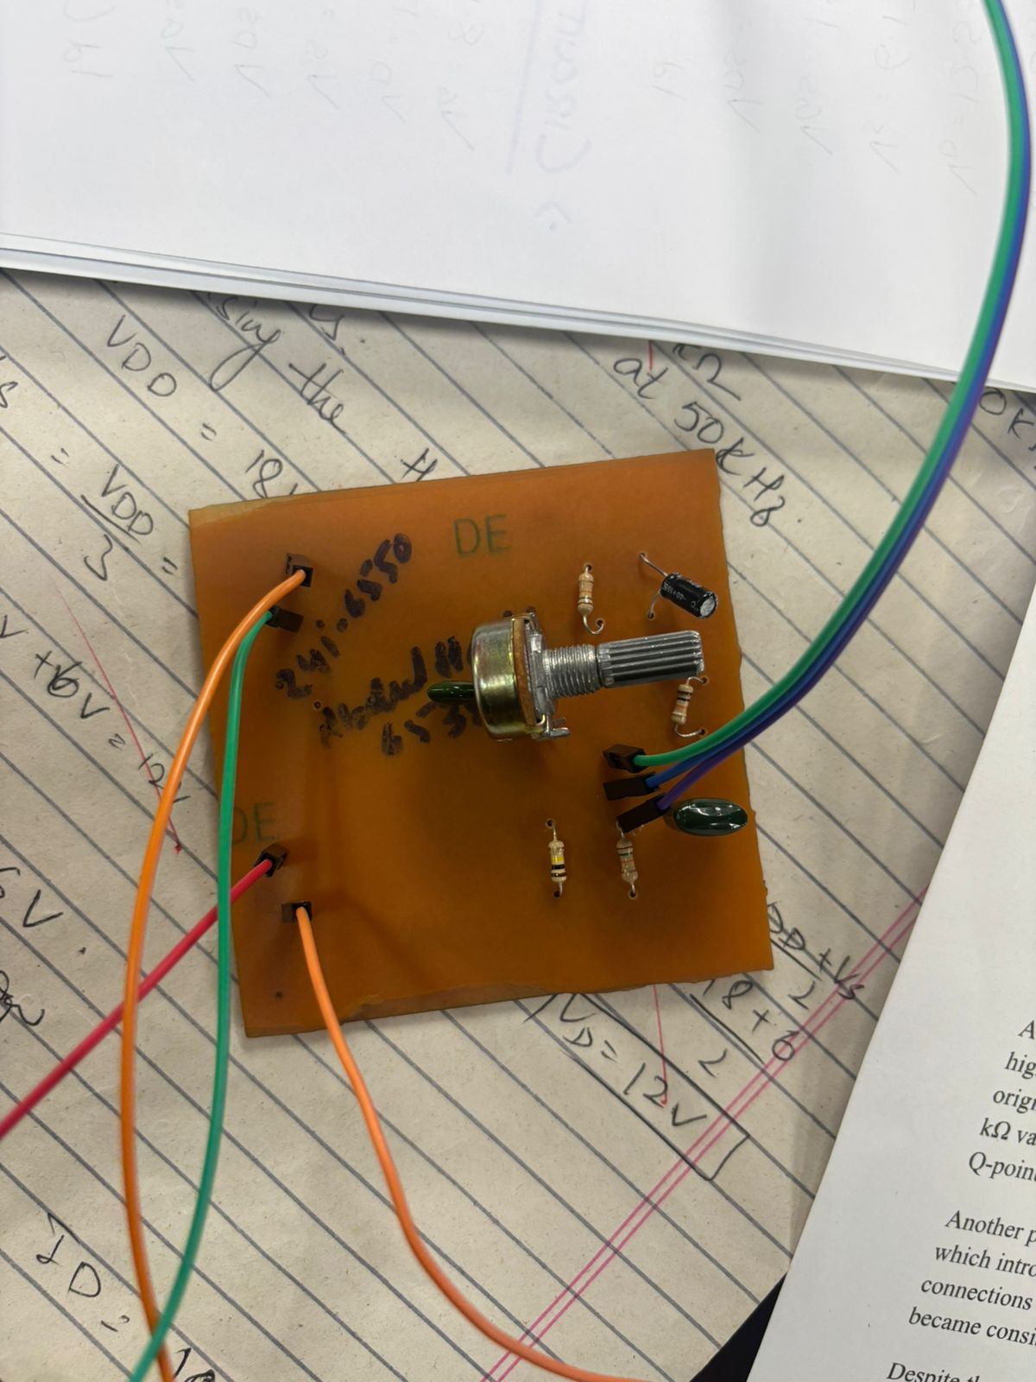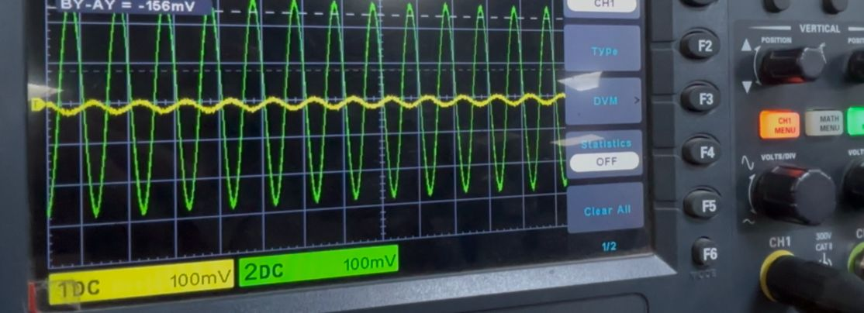

Conclusion:
A few practicval issues including the loose coonections to the pcb were faced at first but after it they were resolved.oscilloscope probes had loose pins , which at first introduced noise and output was disturbed . it was resolved after using secured probes and switching to better pair of probes.
So bacsically , expected values were observed and a great gain there too .
Attachments:
